ASSIGNMENT
Step 1: Update repository.

Step 2: Upgrade repository

Step 3: Install jdk.

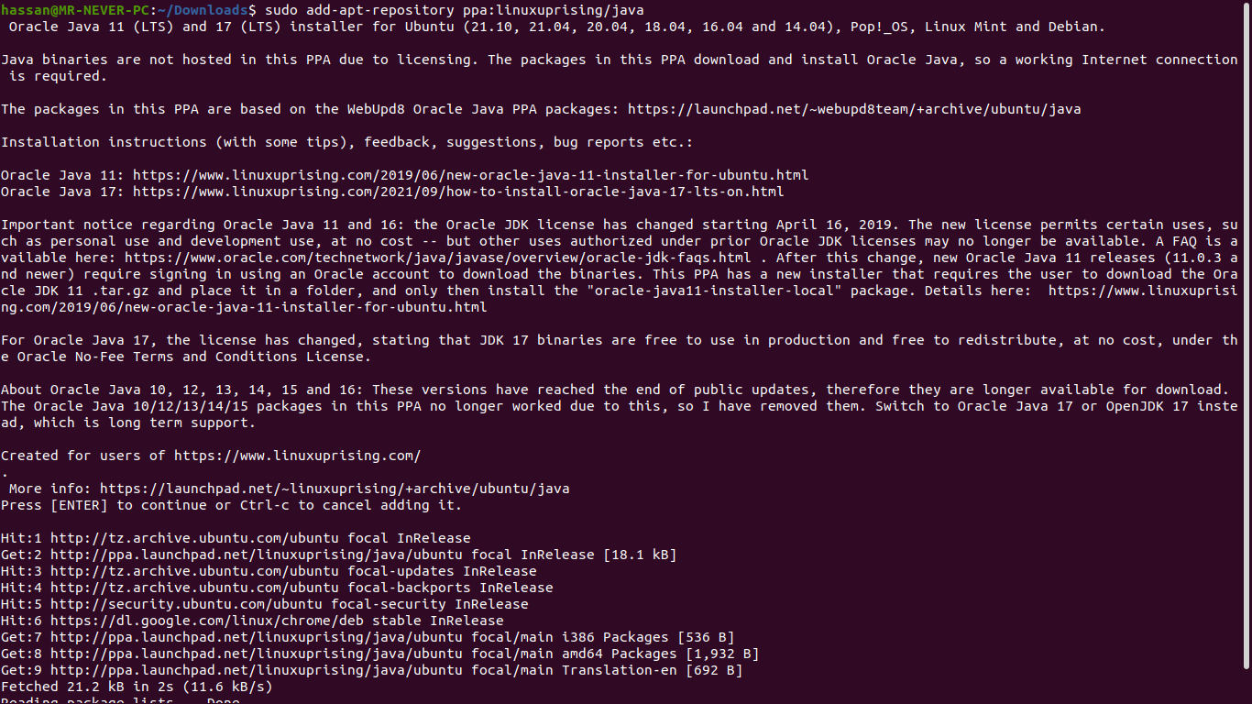

Next

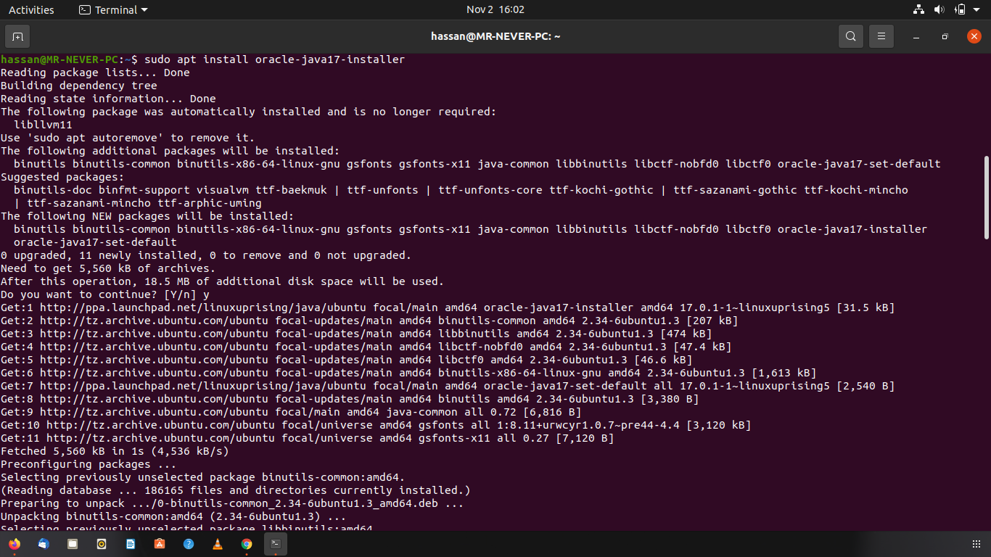

Next

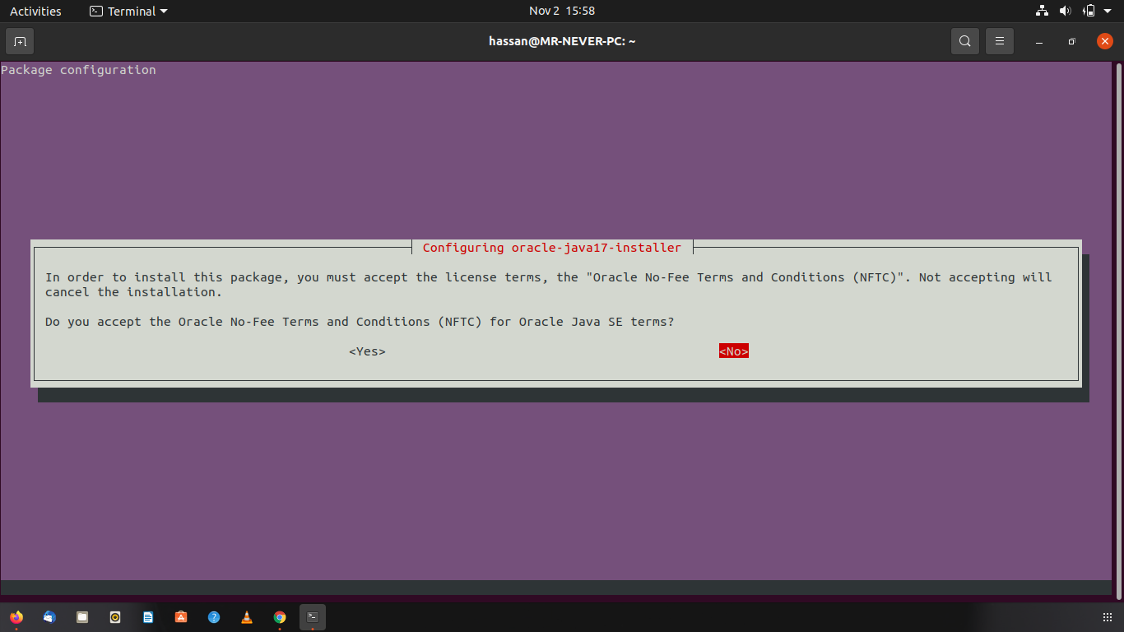
Done.

Step 4: Testing

- java

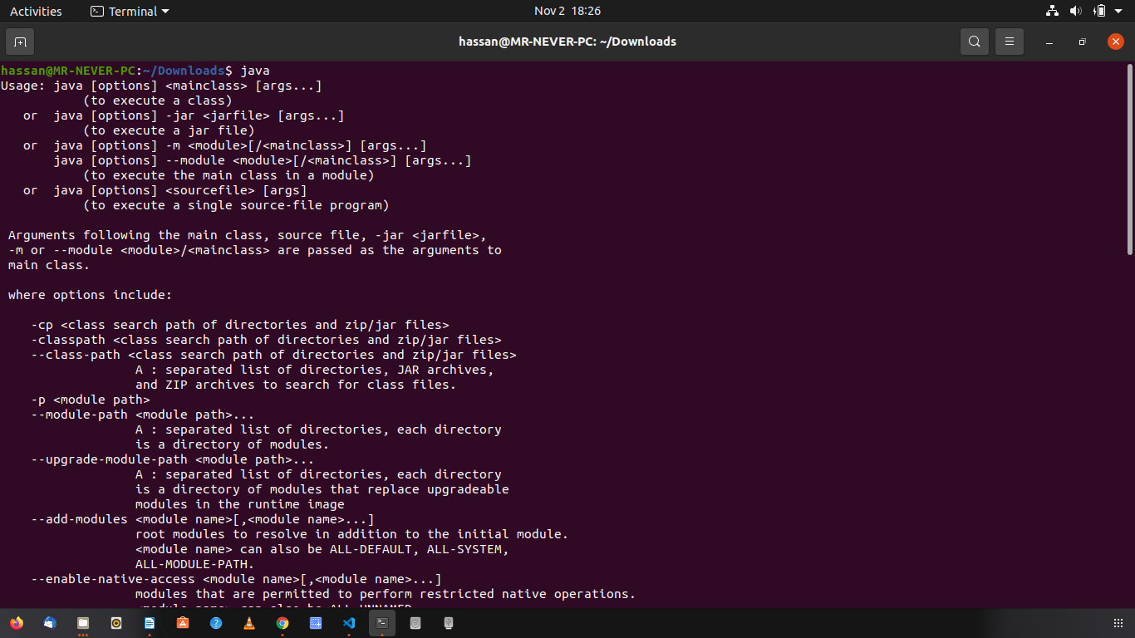

- javac

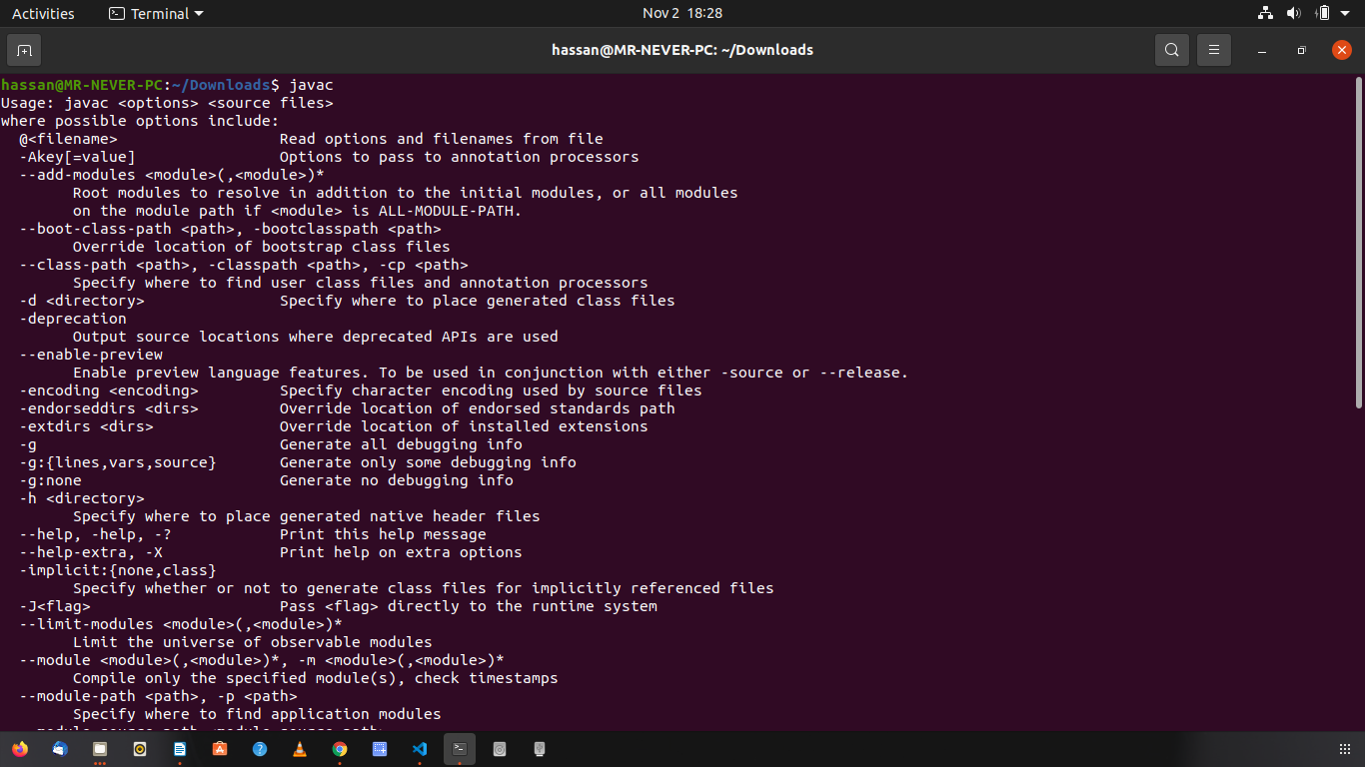
- java –version

